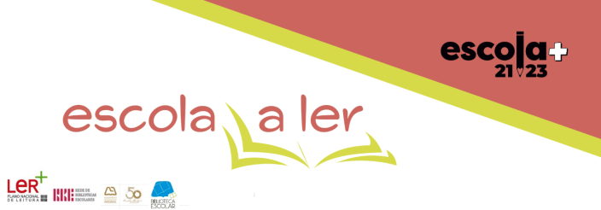 **Projeto "10 Minutos a Ler" – 1º Período**

**ANO – 5º TURMA – B _ Coja**

|  |  |  |  |  |  |  |  |  |  |  |  |  |  |  |  |  |  |  |  |  |  |  |  |  |  |  |  |  |  |  |  |  |  |
| --- | --- | --- | --- | --- | --- | --- | --- | --- | --- | --- | --- | --- | --- | --- | --- | --- | --- | --- | --- | --- | --- | --- | --- | --- | --- | --- | --- | --- | --- | --- | --- | --- | --- |
| **Mês/Dias** | **S** | **D** | **2ª** | **3ª** | **4ª** | **5ª** | **6ª** | **S** | **D** | **2ª** | **3ª** | **4ª** | **5ª** | **6ª** | **S** | **D** | **2ª** | **3ª** | **4ª** | **5ª** | **6ª** | **S** | **D** | **2ª** | **3ª** | **4ª** | **5ª** | **6ª** | **S** | **D** | **2ª** | **3ª** | **4ª** |
| **Outubro** | **1** | **2** | **3** | **4** | **5** | **6** | **7** | **8** | **9** | **10** | **11** | **12** | **13** | **14** | **15** | **16** | **17** | **18** | **19** | **20** | **21** | **22** | **23** | **24** | **25** | **26** | **27** | **28** | **29** | **30** | **31** |  |  |
|  |  | **MAT** |  | **Feriado** | **PORT** |  |  |  | **ING** |  | **ET** |  |  |  |  | **HGP** |  |  | **CN** |  |  |  |  | **EF** |  |  | **EMR** |  |  | **EV** |  |  |
| **Novembro** |  |  |  | **1** | **2** | **3** | **4** | **5** | **6** | **7** | **8** | **9** | **10** | **11** | **12** | **13** | **14** | **15** | **16** | **17** | **18** | **19** | **20** | **21** | **22** | **23** | **24** | **25** | **26** | **27** | **28** | **29** | **30** |
|  |  |  | **Feriado** | **EM / CED** |  | **TIC** |  |  | **MAT** |  |  | **PORT** |  |  |  | **ING** |  | **ET** |  |  |  |  | **HGP** |  |  | **CN** |  |  |  |  | **EF** |  |
| **Dezembro** |  |  |  |  |  | **1** | **2** | **3** | **4** | **5** | **6** | **7** | **8** | **9** | **10** | **11** | **12** | **13** | **14** | **15** | **16** |  |  |  |  |  |  |  |  |  |  |  |  |
|  |  |  |  |  | **Feriado** | **EMR** |  |  |  |  | **EM / CED** | **Feriado** | **TIC** |  |  | **EV** |  |  | **PORT** |  |  |  |  |  |  |  |  |  |  |  |  |  |

**A Diretora de Turma:**

Ana Barros